DJ Wilkins 2021-22 Season Analysis (Against D1 Teams only)

**Win vs Loss Statistics:**

* 20-9 in games DJ played
* 45% FG% in Wins, 31% FG% in Losses.
* 56% 2P FG% in Wins, 29% 2P FG% in Losses
* Attempted 3.15 2P and 5.00 3P in Wins, 4.22 2P and 4.78 3P in losses.
  + **Could conclude from this that a 3-pointer is a higher quality shot for DJ**, which describes the large discrepancy between his FG% in Wins and Losses
* 2.2 AST in Wins, 0.89 AST in Losses.
  + In 6 game stretch where Roman was hurt, he averaged 3.33 AST
  + In games DJ and Roman played together, 1.87 AST in Wins, .5 AST in Losses
* 1.1 TOV in Wins, 2.11 TOV in Losses.
* 10.75 PPG in Wins, 8.67 PPG in Losses.
* 1.60 RPG in Wins, .78 RPG in Losses.
  + I know DJ isn’t a big rebounder, but he had more than double the number of rebounds in wins.
* 13-5 when DJ scored 10+ points
* 6-1 when DJ scored 15+ points
* 11-5 when DJ attempted 5+ 3P, shot 41% in those games
* 6-3 when DJ made 3+ 3P
* 1-3 when DJ had 3+ Turnovers
* Averaged 11.3 PPG when playing 30+ min, compared to his 10.1 PPG season average
  + Signals his playing time was on an efficient schedule

This data would lead us into believing that DJ’s performance was very significant in predicting whether we won or lost. Next, I’ll create a random forest to see if there’s proof of this.

Random Forest Results:   
This type of model runs through our schedule 1000 times and predicts, given the statistics of the game log, whether we won or lost.

* DJ’s random forest was 73% accurate overall
* 82% accurate in games we won (meaning when the model predicted a win, we did actually win the game)
  + Similar to the overall team data, when we won games, DJ’s play was more predictive

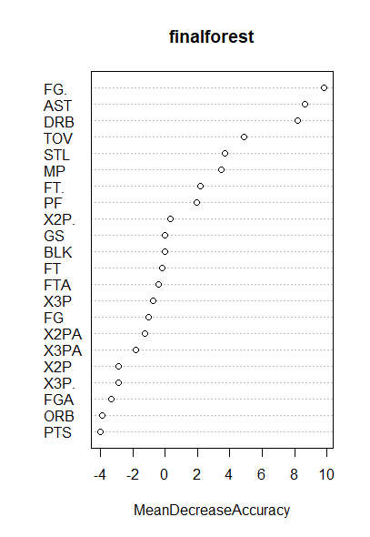

* The random forest echoes my previous statements about Assists, FG%, Rebounds, and Turnovers for DJ
  + Each of these statistics has a “MeanDecreaseAccuracy” over 4, thus they are statistically significant
  + This gives statistical evidence that DJ’s field goal percentage, defensive rebounds, assists, and turnovers were very significant in predicting whether we won or lost